Part 1

I used below algorithm by seeing a lecture note.

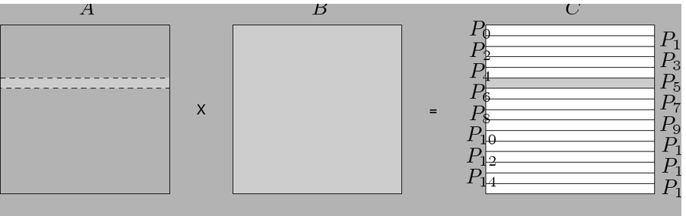

I can find a reason why the algorithm above is faster than naïve algorithm in the most used 3rd for loop. Columns of array2 and array4 move due to j value

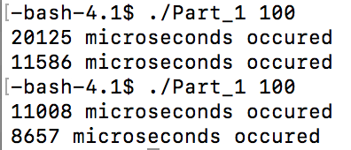

First one is the naïve implementation and latter one is the optimized implementation.